Step-by-Step: Online Purchase of a 20/21 Payback

- Navigate to www.paybackbook.com & click blue ‘Purchase 20/21 Payback Book’ button

- Click ‘Referred by a School or group? Click here!’ button

- Fill in your full name, email address, student’s first and last name and select Grass Valley Elementary from the ‘School or Group Name’ drop down. Filling in the student’s name makes them eligible to win prizes!
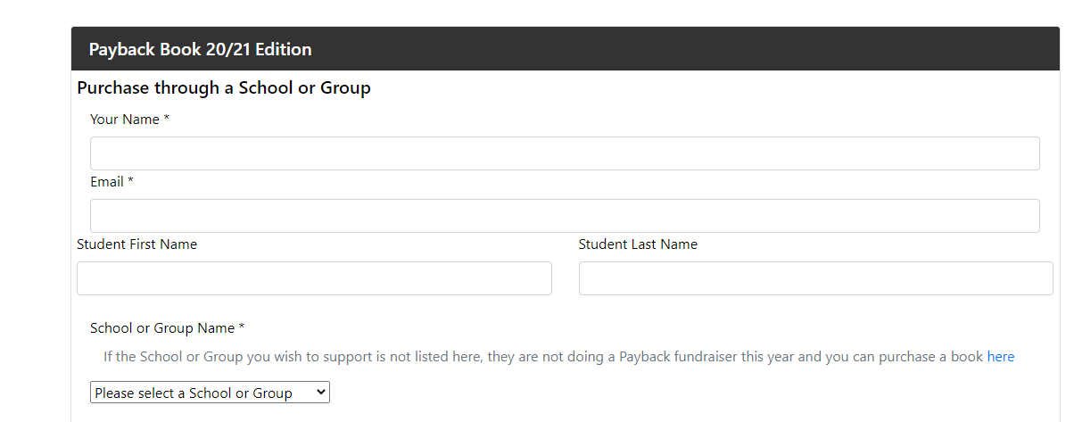
This selection ensures our school receives the proceeds from the sale

- On this same page fill in your address, number of books ordering and credit card information
Shipping is $4.99 no matter how many books you order!

Also, the credit card space can be easy to miss. It is right above the ‘Pay’ button.
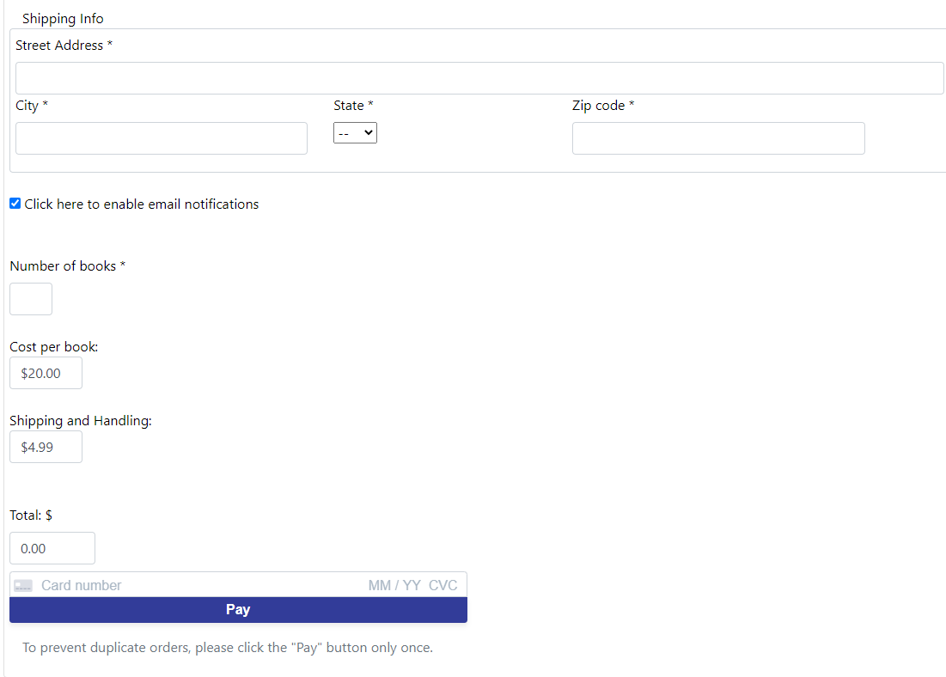

Congratulations! You have successfully supported the Grass Valley Elementary students and teachers!
